**Practical No 04**

**X.1**

* **Program:**

<?xml version="1.0" encoding="utf-8"?>

<androidx.constraintlayout.widget.ConstraintLayout

xmlns:android="http://schemas.android.com/apk/res/android"

xmlns:app="http://schemas.android.com/apk/res-auto"

xmlns:tools="http://schemas.android.com/tools"

android:layout_width="match_parent"

android:layout_height="match_parent"

tools:context=".MainActivity">

<TextView

android:id="@+id/textView"

android:layout_width="wrap_content"

android:layout_height="wrap_content"

android:layout_marginBottom="191dp"

android:text="Hello! Welcome to Android Studio"

android:textSize="20dp"

app:layout_constraintBottom_toTopOf="@+id/button"

app:layout_constraintEnd_toEndOf="parent"

app:layout_constraintStart_toStartOf="parent"

app:layout_constraintTop_toTopOf="parent" />

<Button

android:id="@+id/button"

android:layout_width="wrap_content"

android:layout_height="wrap_content"

android:text="Next"

app:layout_constraintBottom_toBottomOf="parent"

app:layout_constraintEnd_toEndOf="parent"

app:layout_constraintStart_toStartOf="parent"

app:layout_constraintTop_toTopOf="parent"

app:layout_constraintVertical_bias="0.781" />

</androidx.constraintlayout.widget.ConstraintLayout>

* **Output:**

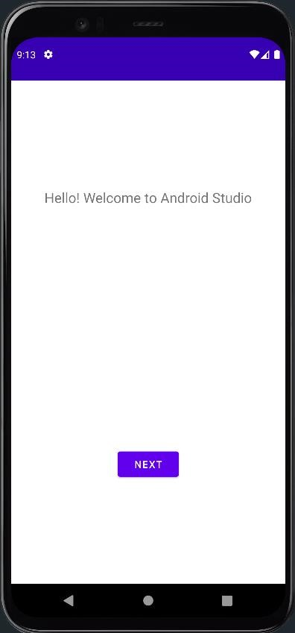

**X.2**

* **Program:**

<?xml version="1.0" encoding="utf-8"?>

<androidx.constraintlayout.widget.ConstraintLayout

xmlns:android="http://schemas.android.com/apk/res/android"

xmlns:tools="http://schemas.android.com/tools"

android:layout_width="match_parent"

android:layout_height="match_parent"

tools:context=".MainActivity">

<LinearLayout

android:layout_width="412dp"

android:layout_height="733dp"

android:orientation="vertical"

tools:layout_editor_absoluteX="1dp"

tools:layout_editor_absoluteY="1dp">

<TextView

android:id="@+id/textView"

android:layout_width="wrap_content"

android:layout_height="wrap_content"

android:text="Student Name"

android:textSize="24sp" />

<EditText

android:id="@+id/editTextTextPersonName"

android:layout_width="wrap_content"

android:layout_height="wrap_content"

android:ems="10"

android:inputType="textPersonName"

android:textSize="24sp"/>

<TextView

android:id="@+id/textView2"

android:layout_width="wrap_content"

android:layout_height="wrap_content"

android:text="Marks"

android:textSize="24sp"/>

<EditText

android:id="@+id/editTextNumber"

android:layout_width="288dp"

android:layout_height="wrap_content"

android:ems="10"

android:inputType="number"

android:textSize="24sp" />

</LinearLayout>

</androidx.constraintlayout.widget.ConstraintLayout>

* **Output:**

